|  |  |
| --- | --- |
| **Name** |  |

***Full working out must be shown to get full marks.***

***Attempt all questions***

**Total Time: 60 minutes**

* **Section 1 (Calculator Free): 40 minutes 39 marks**
* **Section 2 (Calculator Assisted): 20 minutes 17 marks**

**Calculator Free**

**Question 1 [2, 2, 3 = 7 marks]**

1. Rewrite the equation y = 2(x – 4)2 + 7 in the form of y = ax+ bx + c
2. For the graph *y* = a*x*2 + *x* – 1 determine the value of a if the graph passes through

the point ( - 4 , 11 )

1. The graph of *y* = *x*2 + *px* +*q* has a turning point at (6, -3). Determine the coordinates of the *y* -intercept of the parabola.

**Question 2 [1, 1, 1, 2, 2 = 7 marks]**

1. What are the coordinates of the -intercept of the graph of ?
2. State the number of roots of the graph of .
3. What are the coordinates of the turning point of the graph of?
4. What is the equation of the line of symmetry of the graph of ?
5. Determine the equation of the quadratic function that passes through the point (0, -9) and has a turning point at (-2, 3).

**Question 3 [2 Marks]**

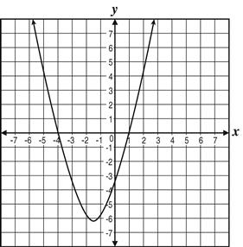 The graph of **https://opt-prod.s3.amazonaws.com/traject/files/itembank_image_binaries/relateds/000/050/807/original/mml1753501.png?1434062221** is shown.

Determine the value of b

**Question 4 [6 marks : 2, 2, 2]**

Express the quadratic equation ${y=x}^{2}-8x+15$ in the form:

a) $y=a(x-b)(x-c)$ b) $y=a{(x-b)}^{2}+c$

c) Solve the equation $x^{2}-8x+15=0$ using the quadratic formula

**Question 5 [2, 2, 6 = 10 marks]**

A quadratic function is given by $f\left(x\right)={\left(x-2\right)}^{2}-9$.

**a)** The function can also be written in the form $f\left(x\right)=x^{2}+bx+c$.

Determine the values of $b$ and $c$.

**b)** Solve the equation $f\left(x\right)=0$.

**c)** For the graph of , state:

* 1. The coordinates of the turning point.
  2. The equation of the line of symmetry.
  3. The coordinates of all axes intercepts.
  4. Draw a sketch of the graph using the above information

**Question 6 [7 marks : 1, 2, 2, 2]**

For the equation y = 2x2 - 4x + 6 determine;

1. the y-intercept
2. the line of symmetry
3. the coordinates of the turning point
4. Use the discriminant to determine the number of solutions.
5. Draw a sketch of the graph using the above information

**Mathematics Methods**

**Semester 1 2017**

**Calculator Assumed**

**Question 7 [8 marks]**

Complete the table below.

|  |  |  |  |  |  |
| --- | --- | --- | --- | --- | --- |
| Rule | y−intercept | roots | line of  symmetry | turning  point |  |
| y = 15x2− 11x − 12 |  |  |  |  |  |
|  |  | (6,0) and (-2,0) |  | ( ___ , -8) |  |

**Question 8 [3 marks]**

Isabel throws a ball for her dog to catch. The path of the ball is parabolic and can be modeled by the equation  where *h* is the height in metres of the ball above the ground and *x* is the horizontal distance of the ball from Isabel.

If Isabel’s dog is 4m away from her, how far does he have to jump to catch the ball?

Provide a sketch to illustrate your answer.

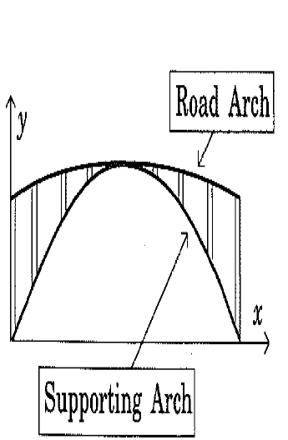**Question 9 [1 + 1 + 2 + 2 = 6 marks]**

A road bridge is to be constructed over a tidal river. The road arch is in the shape of a quadratic function, as is the supporting arch (see diagram).

With *x* and *y* axes as shown, the equations of each arch are as follows:

Road arch: $y=-\frac{x^{2}}{2250}+\frac{2x}{15}+40$

Supporting arch: $y=\frac{2x}{3}-\frac{x^{2}}{450}$

**[1 metre = 1 unit on each axis]**

The *x*-axis is the mean water level with high and low tide levels being four metres either side of this mean.

**a)** Are the road arch and supporting arch, concave up or concave down?

**b)** Calculate the value of *x* at the mid-point of the bridge.

**c)** Calculate the length of the vertical strut between the support arch and the road arch at a point

one-quarter of the way along the bridge.

**d)** Calculate the maximum clearance between the water and bridge at:

**i)** low tide. **ii)** high tide.

End of Test